ChE 391 Homework #3 due 2/23
Boat docking problem:
Docking a motor boat successfully without crashing into the dock can yield a sense of satisfaction to the boat owner/operator. Being able to do this quickly, however, represents a significant challenge to your boatmanship skills. If one ignores waves, wind, and steering effects, the movement of a boat can be described as a tradeoff between viscous forces and the force of the motor/propeller. If these forces are not equal, then the boat can either speed up or slow down. The forward thrust can be expressed as $u$ ((m/sec²)/(1000 kg)), the resistance can be expressed as $b∙v^{2}$, where $b$ ((N∙ sec/m)/(1000 kg) is the measure of friction, which is the damping factor in this system.
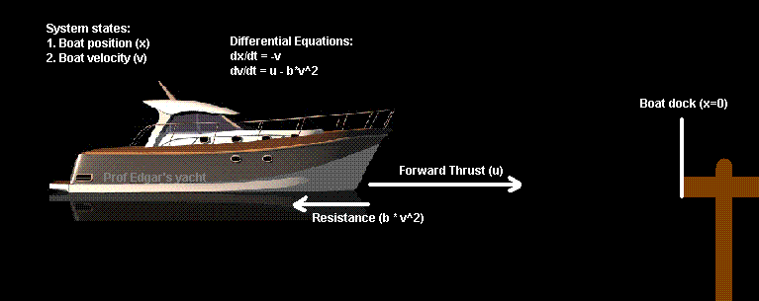
Let the boat position to be $x$, the boat velocity is $v$. Assume the mass of the boat is m=1000 kg, then the boat docking system can be represented by the following equations.
The system equation is:
$$\frac{dx}{dt}=-v$$
$$\frac{dv}{dt}=u-b∙v^{2}$$
Here $-1≤u≤1$, $b=0.05$, $0≤t≤t_{f}$ where $t_{f}$ is the final time when the boat reach the dock.
The initial condition on velocity and position is $x\left(0\right)=100$ (m), and $v\left(0\right)=3$ (m/s). When the boat reaches the dock, the final velocity $v\left(t_{f}\right)$ should be below 0.05 m/s. Try to find the optimal control strategy $u\left(t\right)$ which can minimize the value of $t_{f}$. Simulate your solution by MATLAB and show the responses of x(t), $u\left(t\right)$ and $v\left(t\right)$. Use the principles of optimal control as discussed in class augmented by application of nonlinear programming using tools available such as Excel Solver. Interpret your solution in terms of practicality.

